Amdahl’s Law and Gustafson’s Law explained using analogy

Say that you run a cleaning agency, and someone hires you to shine up a house which is an hour away. You hop into your bus at 8AM, get there at 9, and work for 9 hours by yourself, finishing at 6PM. That's a measure of the total amount of work, you are facing a task that consists of 1/10th bus trip and 9/10ths cleaning (theoretical cleaners don't get lunch breaks).
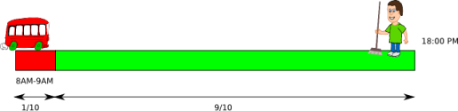
Cleaning goes faster if you have more hands, so if you bring one more person, you can each take 4.5 hours out of the 9, and finish by 13:30. Travelling by bus doesn't go any faster no matter how many people do it at the same time, so that's going to take an hour no matter what you do.
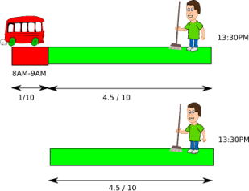
Bring four people, and they can finish cleaning in 2 hours and 15 minutes, but note how the drive begins to account for a substantial part of the overall effort:

I'm sure you can see where this is going. If you keep adding people to the enterprise, cleaning may go faster and faster, but for obvious reasons, your team can never finish before 9AM. Getting there accounts for 1/10th of the total job, so regardless of what you do, no team size can complete this job more than 10 times faster than you can do it alone.
Generally, if a fraction f of a job is impossible to divide into parallel parts, the whole thing can only get 1/f times faster in parallel. That is Amdahl's law.
Now, if you want to make better use of your staff's time, you won't send the whole gang to places where they'll finish in a jiffy and move along, or their time will be spent mostly in transit. Instead, you match up team and job sizes so that everyone you send has exactly enough to do until 18:00 (theoretical customers are very accommodating).
That makes a 2-person job look like this
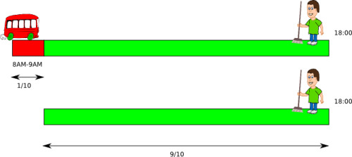

and we can sensibly say that it was done at 2−1/10=1.9 times the speed of 1 person.
Similarly, for a 4-person job
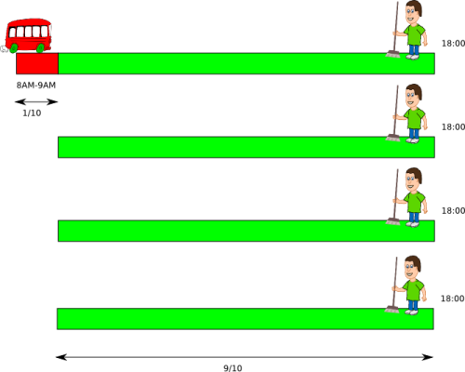
it's 4−3*1/10=3.7 times faster than 1 person, or more generally, p+(1−p) f times faster for p participants, and an un-parallelizable fraction f. That is Gustafson's law.
A way to look at it is that work is going p times as fast as 1 person for the part when they're all cleaning, but only the driver is doing anything useful throughout the bus ride, so we have to subtract p−1 times that for the lost effective time of the p−1 people who are just sitting there.

It's worth noting that while we've been saying 'x times faster' with careless abandon so far,
the two laws start from different assumptions, so their numbers work out differently.
Amdahl's law treats everything as relative to a constant sequential time, so if we apply it to the case where 4 people work 9 hours, the sequential fraction f is 1/37 instead of 1/10.
The other way around, Gustafson's law treats everything as relative to a constant parallel time, so if we apply it to the 4 Amdahl people who finish at 11:15, the sequential fraction f is 1/3.25instead of 1/10.
The matching 'x times faster'-figures are often referred to as speedup and scaled speedup factors respectively,
so as not to confuse them with each other.

One is for telling how big a team you can make use of for a particular job,

the other is for telling how team size affects what you can get done in a day,

